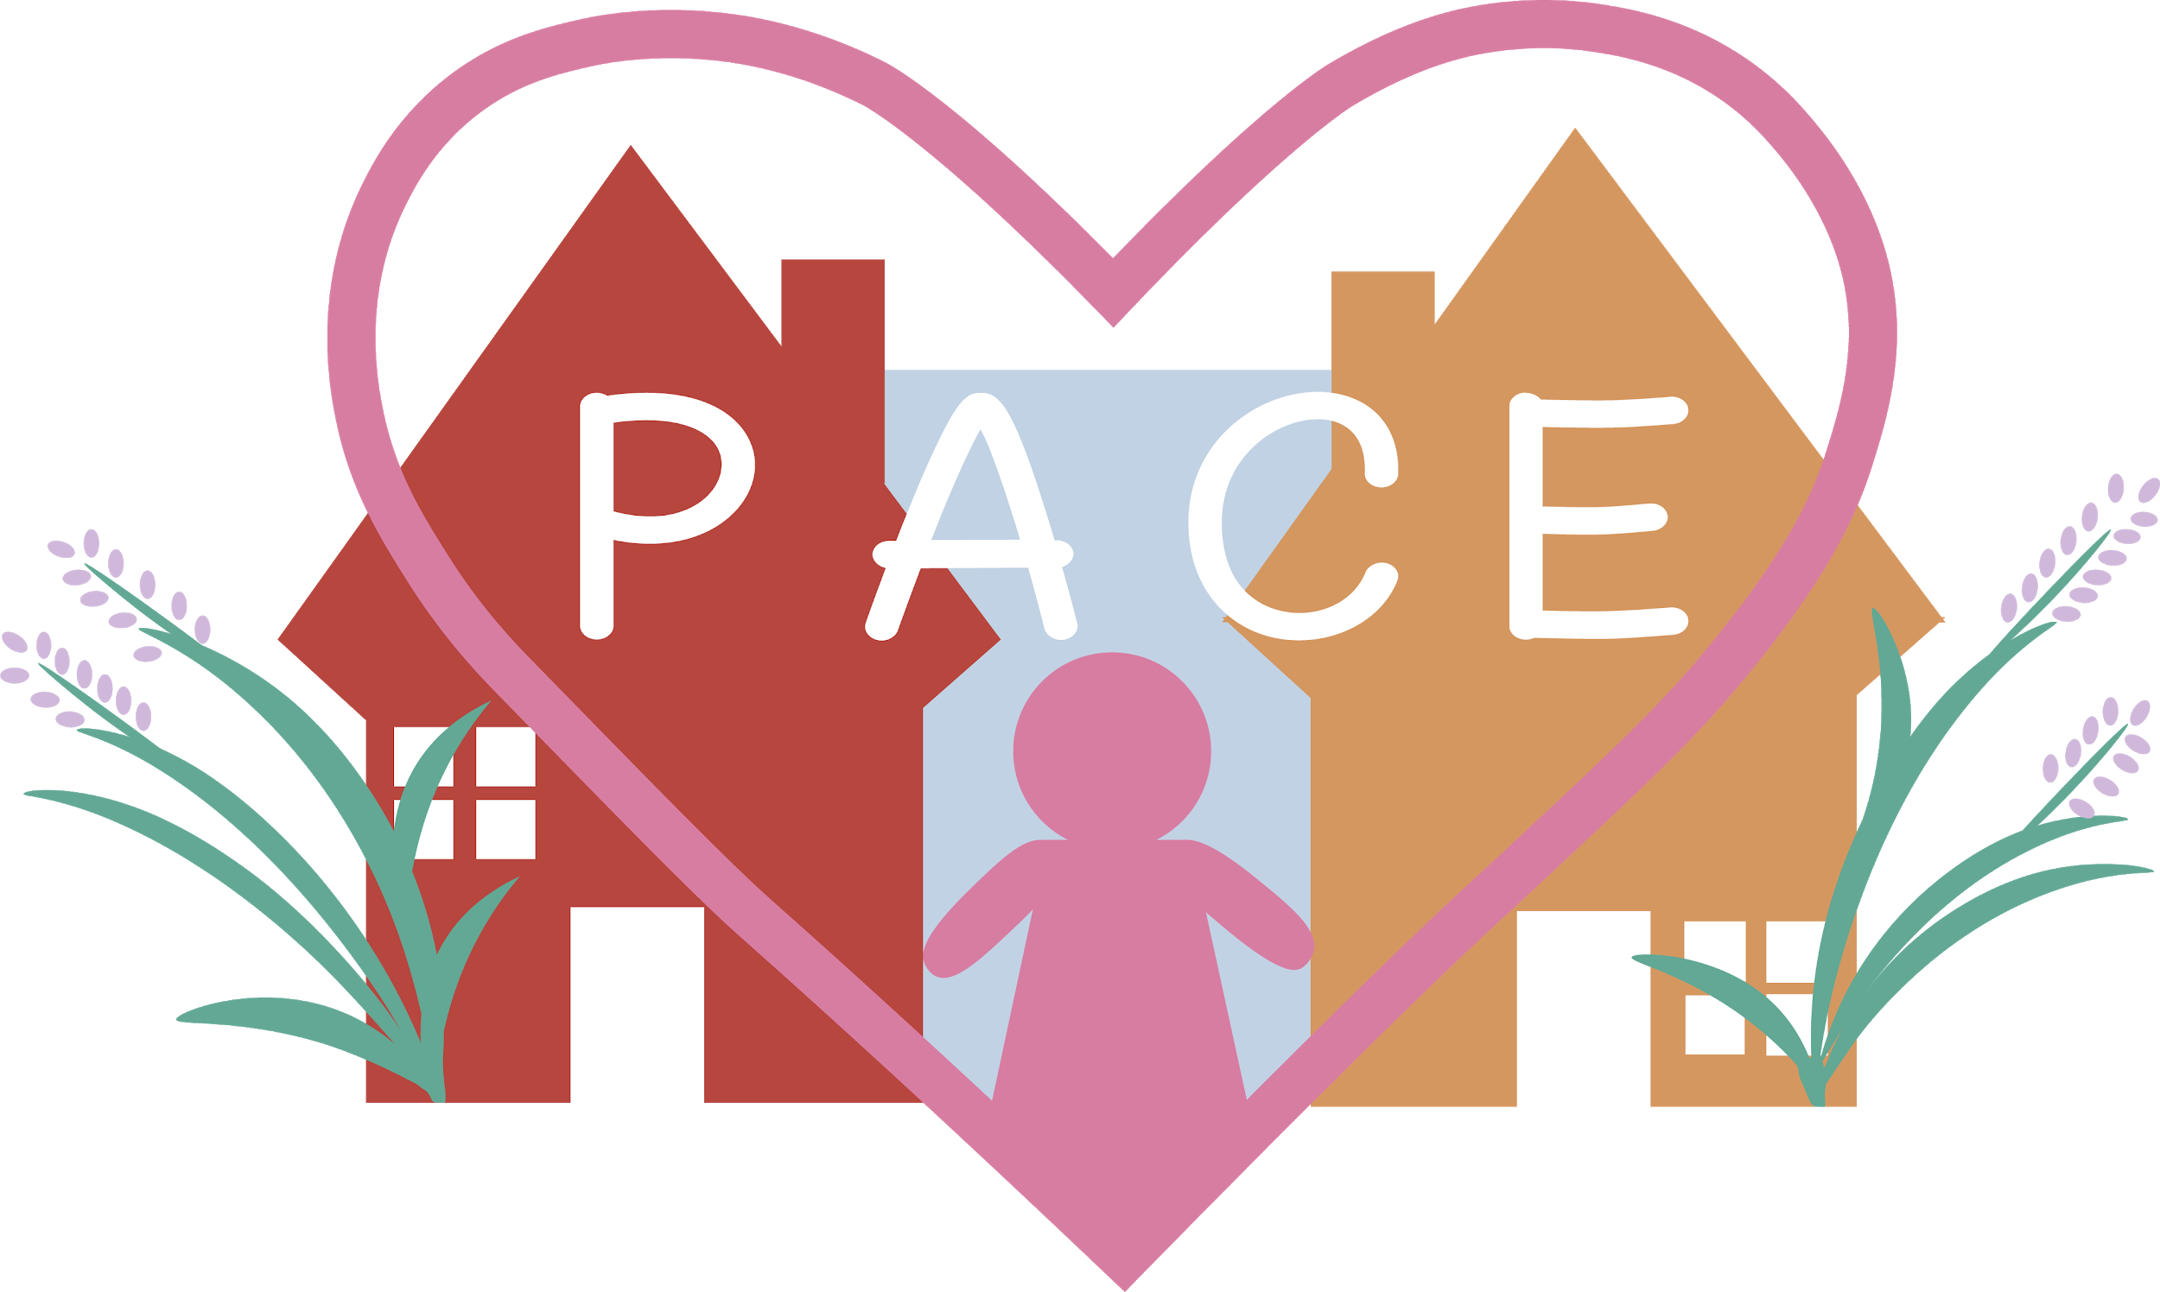

Parenting Apart Centre East Service Charges
Services available Tuesday to Friday 9.30-7.00pm and alternate Saturdays 9.30-4.30pm
NACCC Enhanced Accredited Centre
Preparatory sessions are mandatory for all private referrals
Referral Fee (New Private referrals only)  £36.00 | One off payment, non-refundable-has to be paid prior to any contacts being processed.
Parental Resolution Session  £60.00 per hour | Specific packages to meet the needs of each family. Each parent is allocated a separate practitioner, sessions can be done with both parents in the room or on a shuttle basis. Sessions to hear the ‘voice of the child’ in an age appropriate and child centred way. Includes Parenting Plan.
Handover contacts  £30.00 | Where it is inappropriate or unsafe for parents/carers/guardians to meet we can facilitate handovers.
Tech Contact (Including summary report)  £60.00 an hour  Preparation session £16.00 | Contact using Skype. A preparation session is required prior to first Tech contact.
Supported Contact  Great Yarmouth Contact Centre (Group session 2hrs)  £64.00 for 8 sessions  (Including 2 preparation sessions) | Currently due to COVID 19 sessions will be for an hour to allow for cleaning and also to give as many children as possible an opportunity to see their parent/family member.
Preparation Sessions for private referrals (Each party to have 30 minutes)  £16.00 per party | Each parent/carer/guardian and child or children involved will have time to familiarise themselves with the centre, the expectations, rules and allocated practitioners.
Supported Contact (Private Room or in the community)  £36.00 per hour  Norwich/Lowestoft/Great Yarmouth | This can be in Norwich, Great Yarmouth or Lowestoft, if a different location is required this may incur added costs for room hire and potentially travel.
Supervised Contact Session  £60.00 per hour including summary report. | Actual contact time is 1hr 30 minutes with 15 minutes for the child to settle prior to the session and then 15 minutes feedback at the end for the parent in the session.  Due to COVID 19 where a child has had limited or no indirect contact with the parent a reduced contact time may be appropriate initially.
COVID 19 Contacts  Supervised Community Contact  £60.00 per hour | Where appropriate and safe we will hold contacts in a local park where parent and child can keep a social distance from their practitioner.
Transitional Review  £120.00 for 2 hours | This is optional, but can be very positive in progressing arrangements towards the overall aim of the referral especially in situations where communication between the parents/carers is difficult. Where possible the child’s voice will be included using a method that is age appropriate and their learning development.
Escorted Contact | Individual quotes based on 2 practitioners, mileage and travel.
Reports;  Summary £16.00 per session  Comprehensive £25.00 per session | Please be aware that when professionals are involved the report may only go to them and they will decide whether to share. Private referrals both parents receive a copy of the report independent of who pays for it.  A Summary report is based on Signs of Safety ‘What’s working well?’, ‘What are we concerned about?’ and ‘What needs to happen next?’  A comprehensive report will focus in more detail and may have a specific focus for reporting.

